REACT INTRODUCTION

Contents

Installation Process: 1

Step-1: 1

Step-2 : 2

Step-3 : 3

Error : 4

Step-4: 5

What is JSX? 6

Coding JSX 6

Expressions in JSX 6

Elements Must be Closed 7

Example 7

React Components 7

Class Component 7

Example 7

Function Component 8

Example 8

Rendering a Component 8

Example 8

Routing: 9

What is React-Router? 9

React Lifecycle: 9

# *Installation Process:*

## *Step-1:*

*Download Node Js:* [*https://nodejs.org/en/download/*](https://nodejs.org/en/download/)

[](https://nodejs.org/en/download/)

*\*Note: Use node version latest then npx will work*

*After Installing Check those commands:*

*1.npm –version*

*2.node -v*

*3.npx --version*

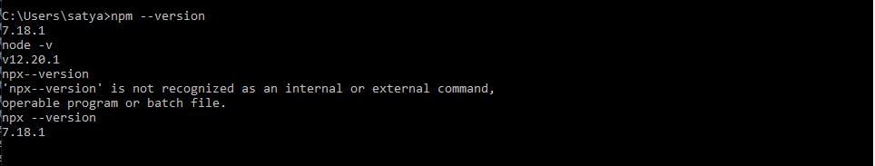

## *Step-2 :*

*Then Create your First React App. First Choose your folder then click SHIFT +Right Click then Poweshell window will be open .See the below image*

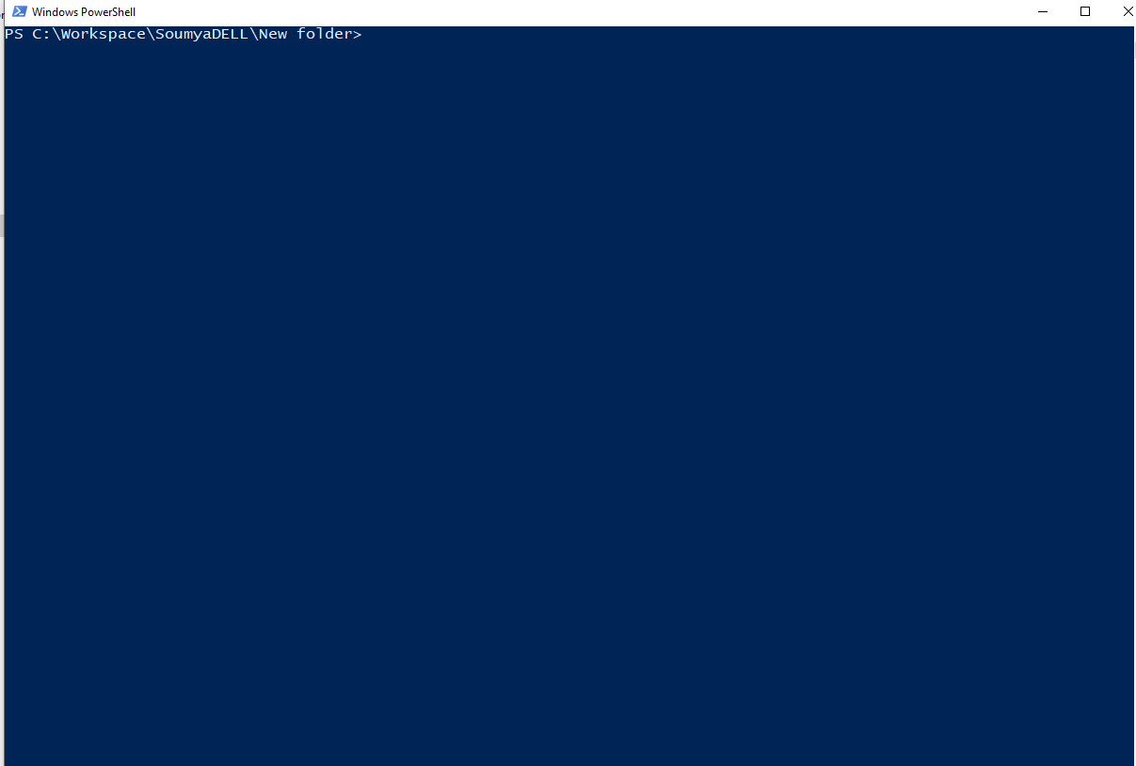

## *Step-3 :*

*Use this command to create your skeleton react app: npx create-react-app my-app (App Name)*

*After installing all the packages it will show like this. See below images*

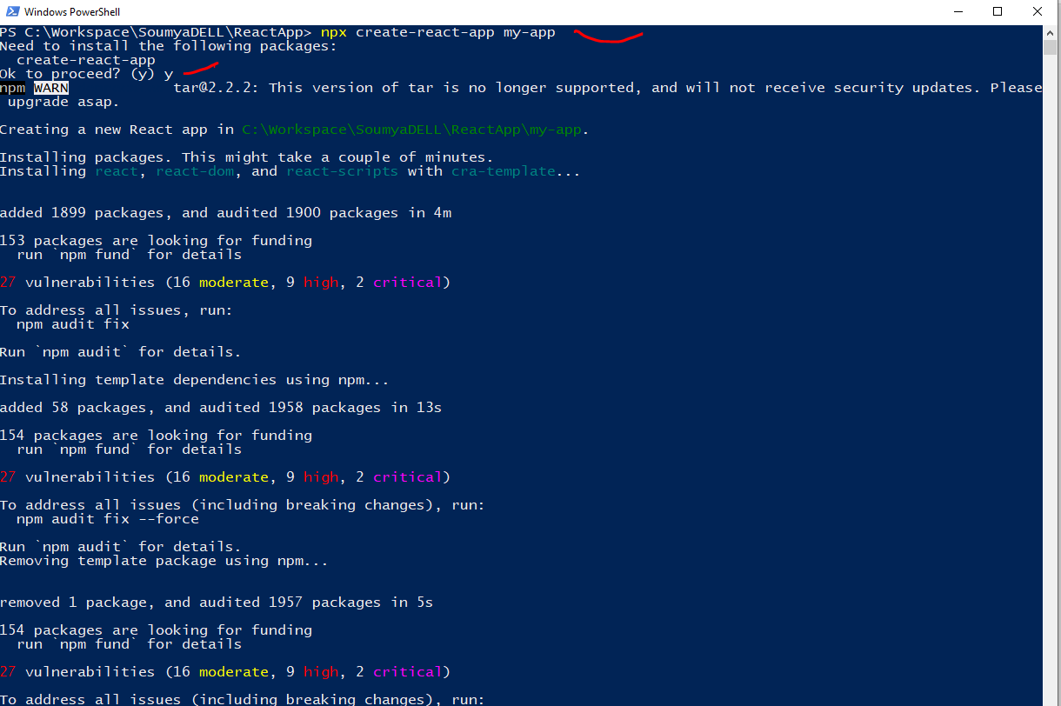

# *Error :*

*If any error comes like this :*

*You are running `create-react-app` 5.0.0, which is behind the latest release (5.0.1).*

*We no longer support global installation of Create React App.*

*Please remove any global installs with one of the following commands:*

*- npm uninstall -g create-react-app*

*- yarn global remove create-react-app*

*The latest instructions for creating a new app can be found here:*

[*https://create-react-app.dev/docs/getting-started/*](https://create-react-app.dev/docs/getting-started/)

*Then you need to follow this command to resolve the issue*

*1. npm uninstall -g create-react-app*

*2. npm install -g create-react-app*

*3. npm cache clean -f*

*4. npx create-react-app my-app*

*See the below images:*

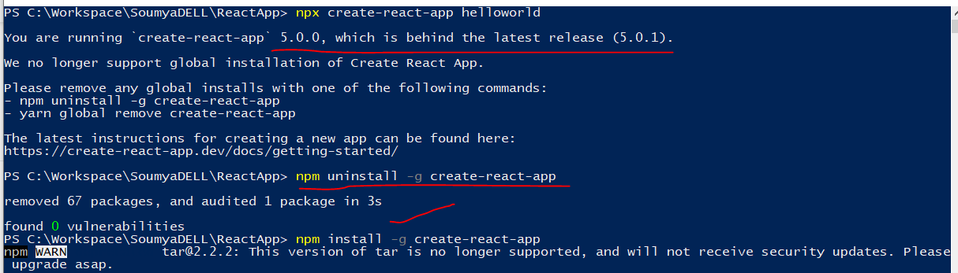

## *Step-4:*

*Needs to start (build) the application Use this command : npm start.*

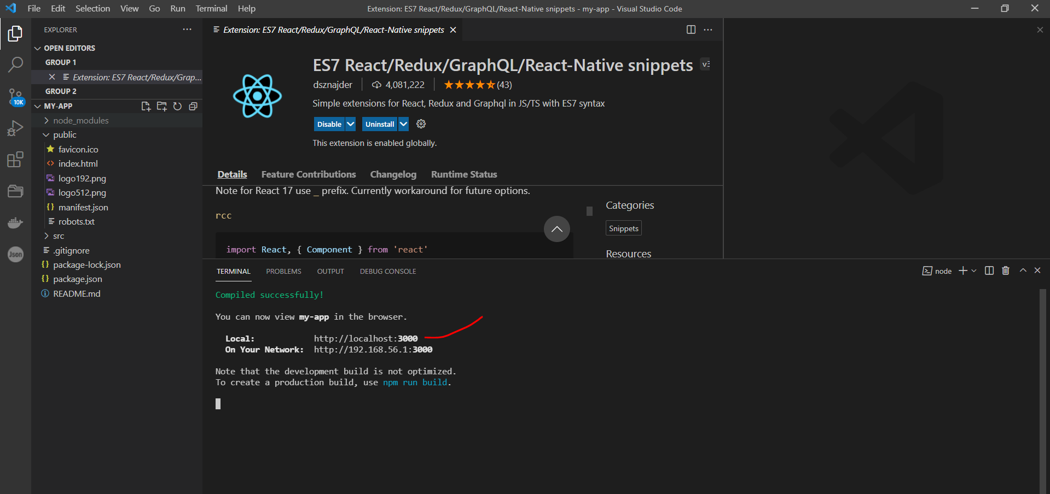

*After successfully build it will open automatically and run on http://localhost:3000 PORT.*

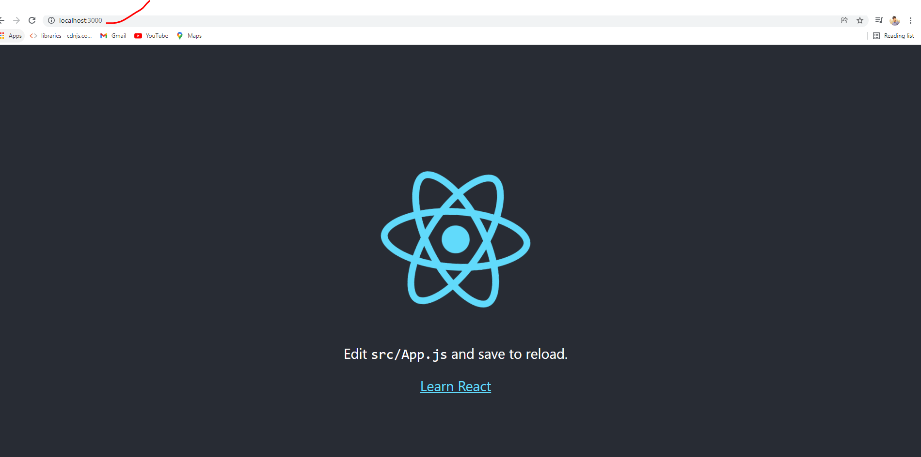

# *What is JSX?*

*JSX stands for JavaScript XML.*

*JSX allows us to write HTML in React.*

*JSX makes it easier to write and add HTML in React.*

# *Coding JSX*

*JSX allows us to write HTML elements in JavaScript and place them in the DOM .*

*JSX converts HTML tags into react elements.*

# *Expressions in JSX*

*With JSX you can write expressions inside curly braces { }.*

*The expression can be a React variable, or property, or any other valid JavaScript expression. JSX will execute the expression and return the result:*

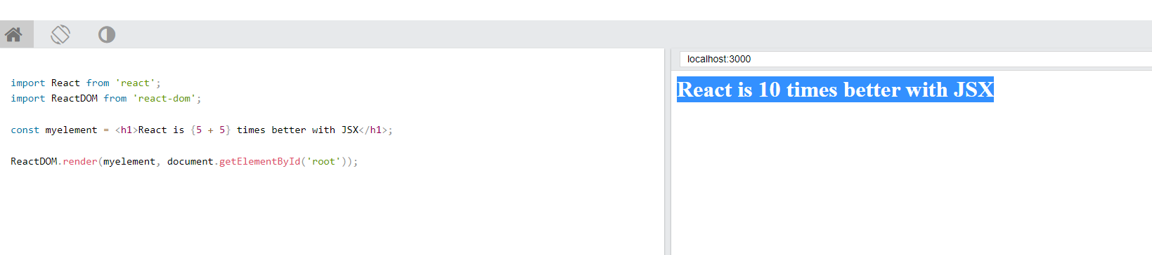

# *Elements Must be Closed*

*JSX follows XML rules, and therefore HTML elements must be properly closed.*

### ***Example***

*Close empty elements with />*

import React from 'react';

import ReactDOM from 'react-dom';

const myelement = <input type="text" />;

ReactDOM.render(myelement, document.getElementById('root'));

# *React Components*

*When creating a React component, the component's name MUST start with an upper case letter.*

# *Class Component*

*A class component must include the extends React.Component statement. This statement creates an inheritance to React.Component, and gives your component access to React.Component's functions.*

*The component also requires a render() method, this method returns HTML.*

### ***Example***

Create a Class component called Car

class Car extends React.Component {

render() {

return <h2>Hi, I am a Car!</h2>;

}

}

# *Function Component*

*Here is the same example as above, but created using a Function component instead.*

*A Function component also returns HTML, and behaves much the same way as a Class component, but Function components can be written using much less code, are easier to understand, and will be preferred in this tutorial.*

### ***Example***

Create a Function component called Car

function Car() {

return <h2>Hi, I am a Car!</h2>;

}

# *Rendering a Component*

*Now your React application has a component called Car, which returns an <h2> element.*

*To use this component in your application, use similar syntax as normal HTML: <Car />*

### ***Example***

Display the Car component in the "root" element:

# *Routing:*

# What is React-Router?

*Many modern websites are actually made up of a single page, they just look like multiple pages because they contain components which render like separate pages.*

*These are usually referred to as SPAs -****s****ingle-****p****age****a****pplications. At its core, what React Router does is conditionally render certain components to display depending on the route being used in the URL (/ for the home page, /about for the about page, etc.).*

# *React Lifecycle:*

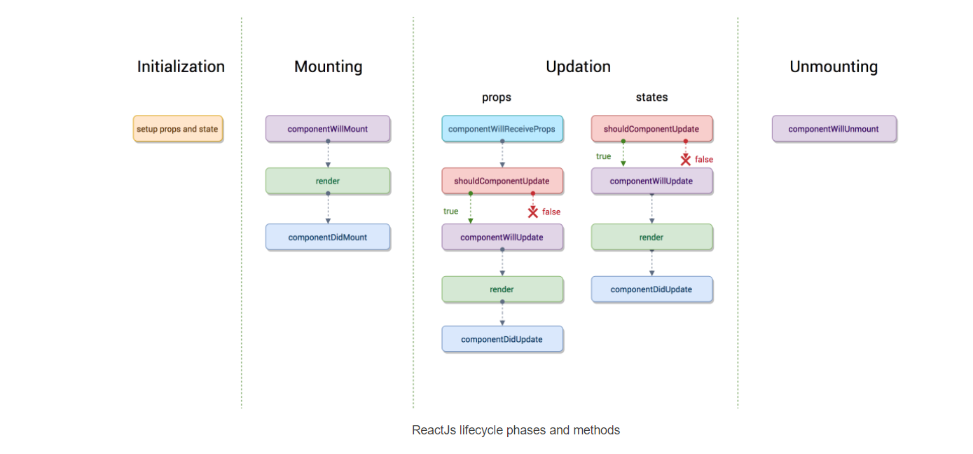

[***https://hackernoon.com/reactjs-component-lifecycle-methods-a-deep-dive-38275d9d13c0***](https://hackernoon.com/reactjs-component-lifecycle-methods-a-deep-dive-38275d9d13c0)